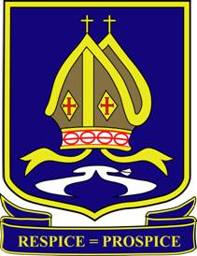
Blue Coat
Church of England Academy

Year: 9 | Subject: Combined Science
Overview

Students follow one of two possible pathways in Science, dependent upon their KS4 option choices.

Those who chose Science as an option will be entered for three separate GCSE’s in Biology, Chemistry and Physics, which provides them with 3 GCSE’s. All other pupils are entered for Combined Science: Trilogy, which provides them with 2 GCSE’s. For both pathways the exams will be a mix of short and long answer questions of 1-6 marks. There will also be some multiple choice questions.

As there is no coursework for the new specification students’ practical skills will be assessed directly in the exam papers, however, there are a few ‘required practicals’ which students are required to carrying out within lessons and answer questions on these in the exam.

GCSE Combined Science: Trilogy

GCSE Combined Science: Trilogy syllabus from AQA is designed to suit students of all abilities, and contains many of the same lessons and required practicals as can be found in GCSE Biology, GCSE Chemistry and GCSE Physics specifications.

There are six 75 minute papers: two biology papers, two chemistry papers and two physics papers, each worth 16.7 %, for which each pupil will gain a double award, equivalent to two GCSEs. This qualification is linear; this means that students will sit all their exams at the end of the two year course.

Through our Kerboodle: AQA GCSE Sciences (9-1) system all students have access to a digital version of the student textbook, exam questions, worksheets, interactive activities, presentations, animations and revision materials.

Biology

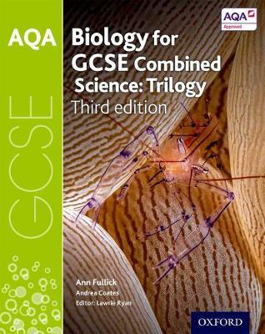
Biology Paper 1
1. Cell biology
2. Organisation
3. Infection and response
4. Bioenergetics

Biology Paper 2
1. Homeostasis and response
2. Inheritance, variation and evolution
3. Ecology

Chemistry

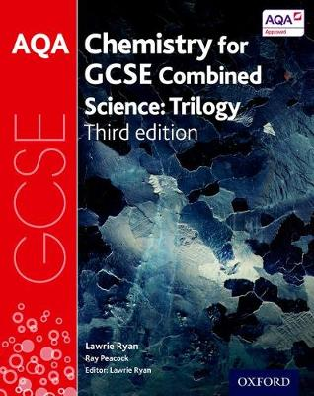
Chemistry Paper 1
1. Atomic structure and the periodic table
2. Bonding, structure, and the properties of matter
3. Quantitative chemistry
4. Chemical changes
5. Energy changes

Chemistry Paper 2
1. The rate and extent of chemical change
2. Organic chemistry
3. Chemical analysis
4. Chemistry of the atmosphere
5. Using resources

Physics

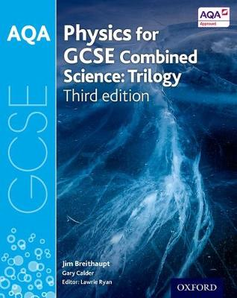
Physics Paper 1
1. Energy
2. Electricity
3. Particle model of matter
4. Atomic structure

Physics paper 2
1. Forces
2. Waves
3. Magnetism and electromagnetism

