P.E. Uniform

P.E. uniform is available to buy from school

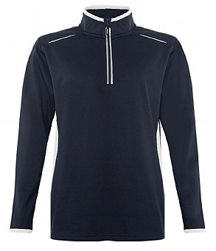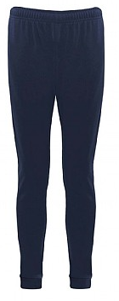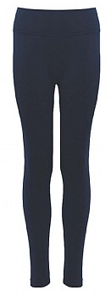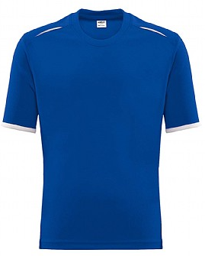

**Blue Coat PE Track Pant**

**£13** (Age 9/10 - 11/13)

**£14** (28/30 and above)

**Blue Coat PE Legging**

**£11.50** (Age 9/10 - 11/13)

**£13** (28/30 and above)

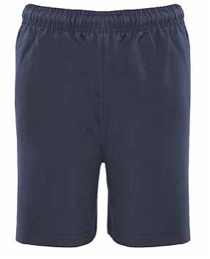

OR

**Blue Coat PE**

**Mid layer**

**£15.50** (age 9-10)

**£17** (30/32 and above)

**Blue Coat PE T-Shirt**

**£9** (All Sizes)

**Blue P.E. Shorts**

**(optional)**

**£7** (All Sizes)

**Prices Effective from 8th April 2024**

**Blue Coat PE Track Pant**

**£12.99** (Age 9/10 - 11/13)

**£13.50** (28/30 +)