 | Size | Unit Price
T-Shirt | Age 9 - 10 | £9.00
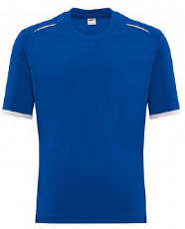 | 30 – 32 | £9.00
 | 32 – 34 | £9.00
 | 34 – 36 | £9.00
 | 38 – 40 | £9.00
 | 42 – 44 | £9.00
 | 46 – 48 | £9.00
 | 50 – 52 | £9.00
Mid-Layer | Age 9 - 10 | £15.50
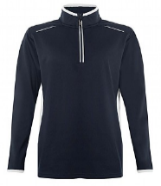 | 30 – 32 | £17.00
 | 32 – 34 | £17.00
 | 34 – 36 | £17.00
 | 38 – 40 | £17.00
 | 42 – 44 | £17.00
 | 46 – 48 | £17.00
 | 50 – 52 | £17.00
Track Pants | Age 9 – 10 | £13.00
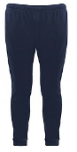 | Age 11 – 13 | £13.00
 | 28 – 30 | £14.00
 | 30 – 32 | £14.00
 | 34 – 36 | £14.00
 | 38 – 40 | £14.00
 | 42 – 44 | £14.00
Leggings | Age 9 – 10 | £11.50
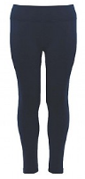 | Age 11 – 13 | £11.50
 | 28 – 30 | £13.00
 | 30 – 32 | £13.00
 | 34 – 36 | £13.00
 | 38 – 40 | £13.00
 | 42 – 44 | £13.00
Shorts | Age 9 – 10 | £7.00
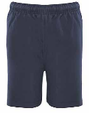 | Age 11 – 13 | £7.00
 | 28 – 30 | £7.00
 | 30 – 32 | £7.00
 | 34 – 36 | £7.00
 | 38 – 40 | £7.00
 | 42 – 44 | £7.00
PE Uniform Sizes

Did you know you can order PE Uniform online?
Please visit: https://www.bluecoatacademy.org/school-uniform/
The P.E. uniform consists of a T-shirt, a mid-layer and either track pants or leggings. Shorts are optional. To minimise the cost to parents/carers, PE uniform can only be purchased directly from the school. Once the label is removed the item cannot be exchanged.
Items will be supplied within 3 working days.

